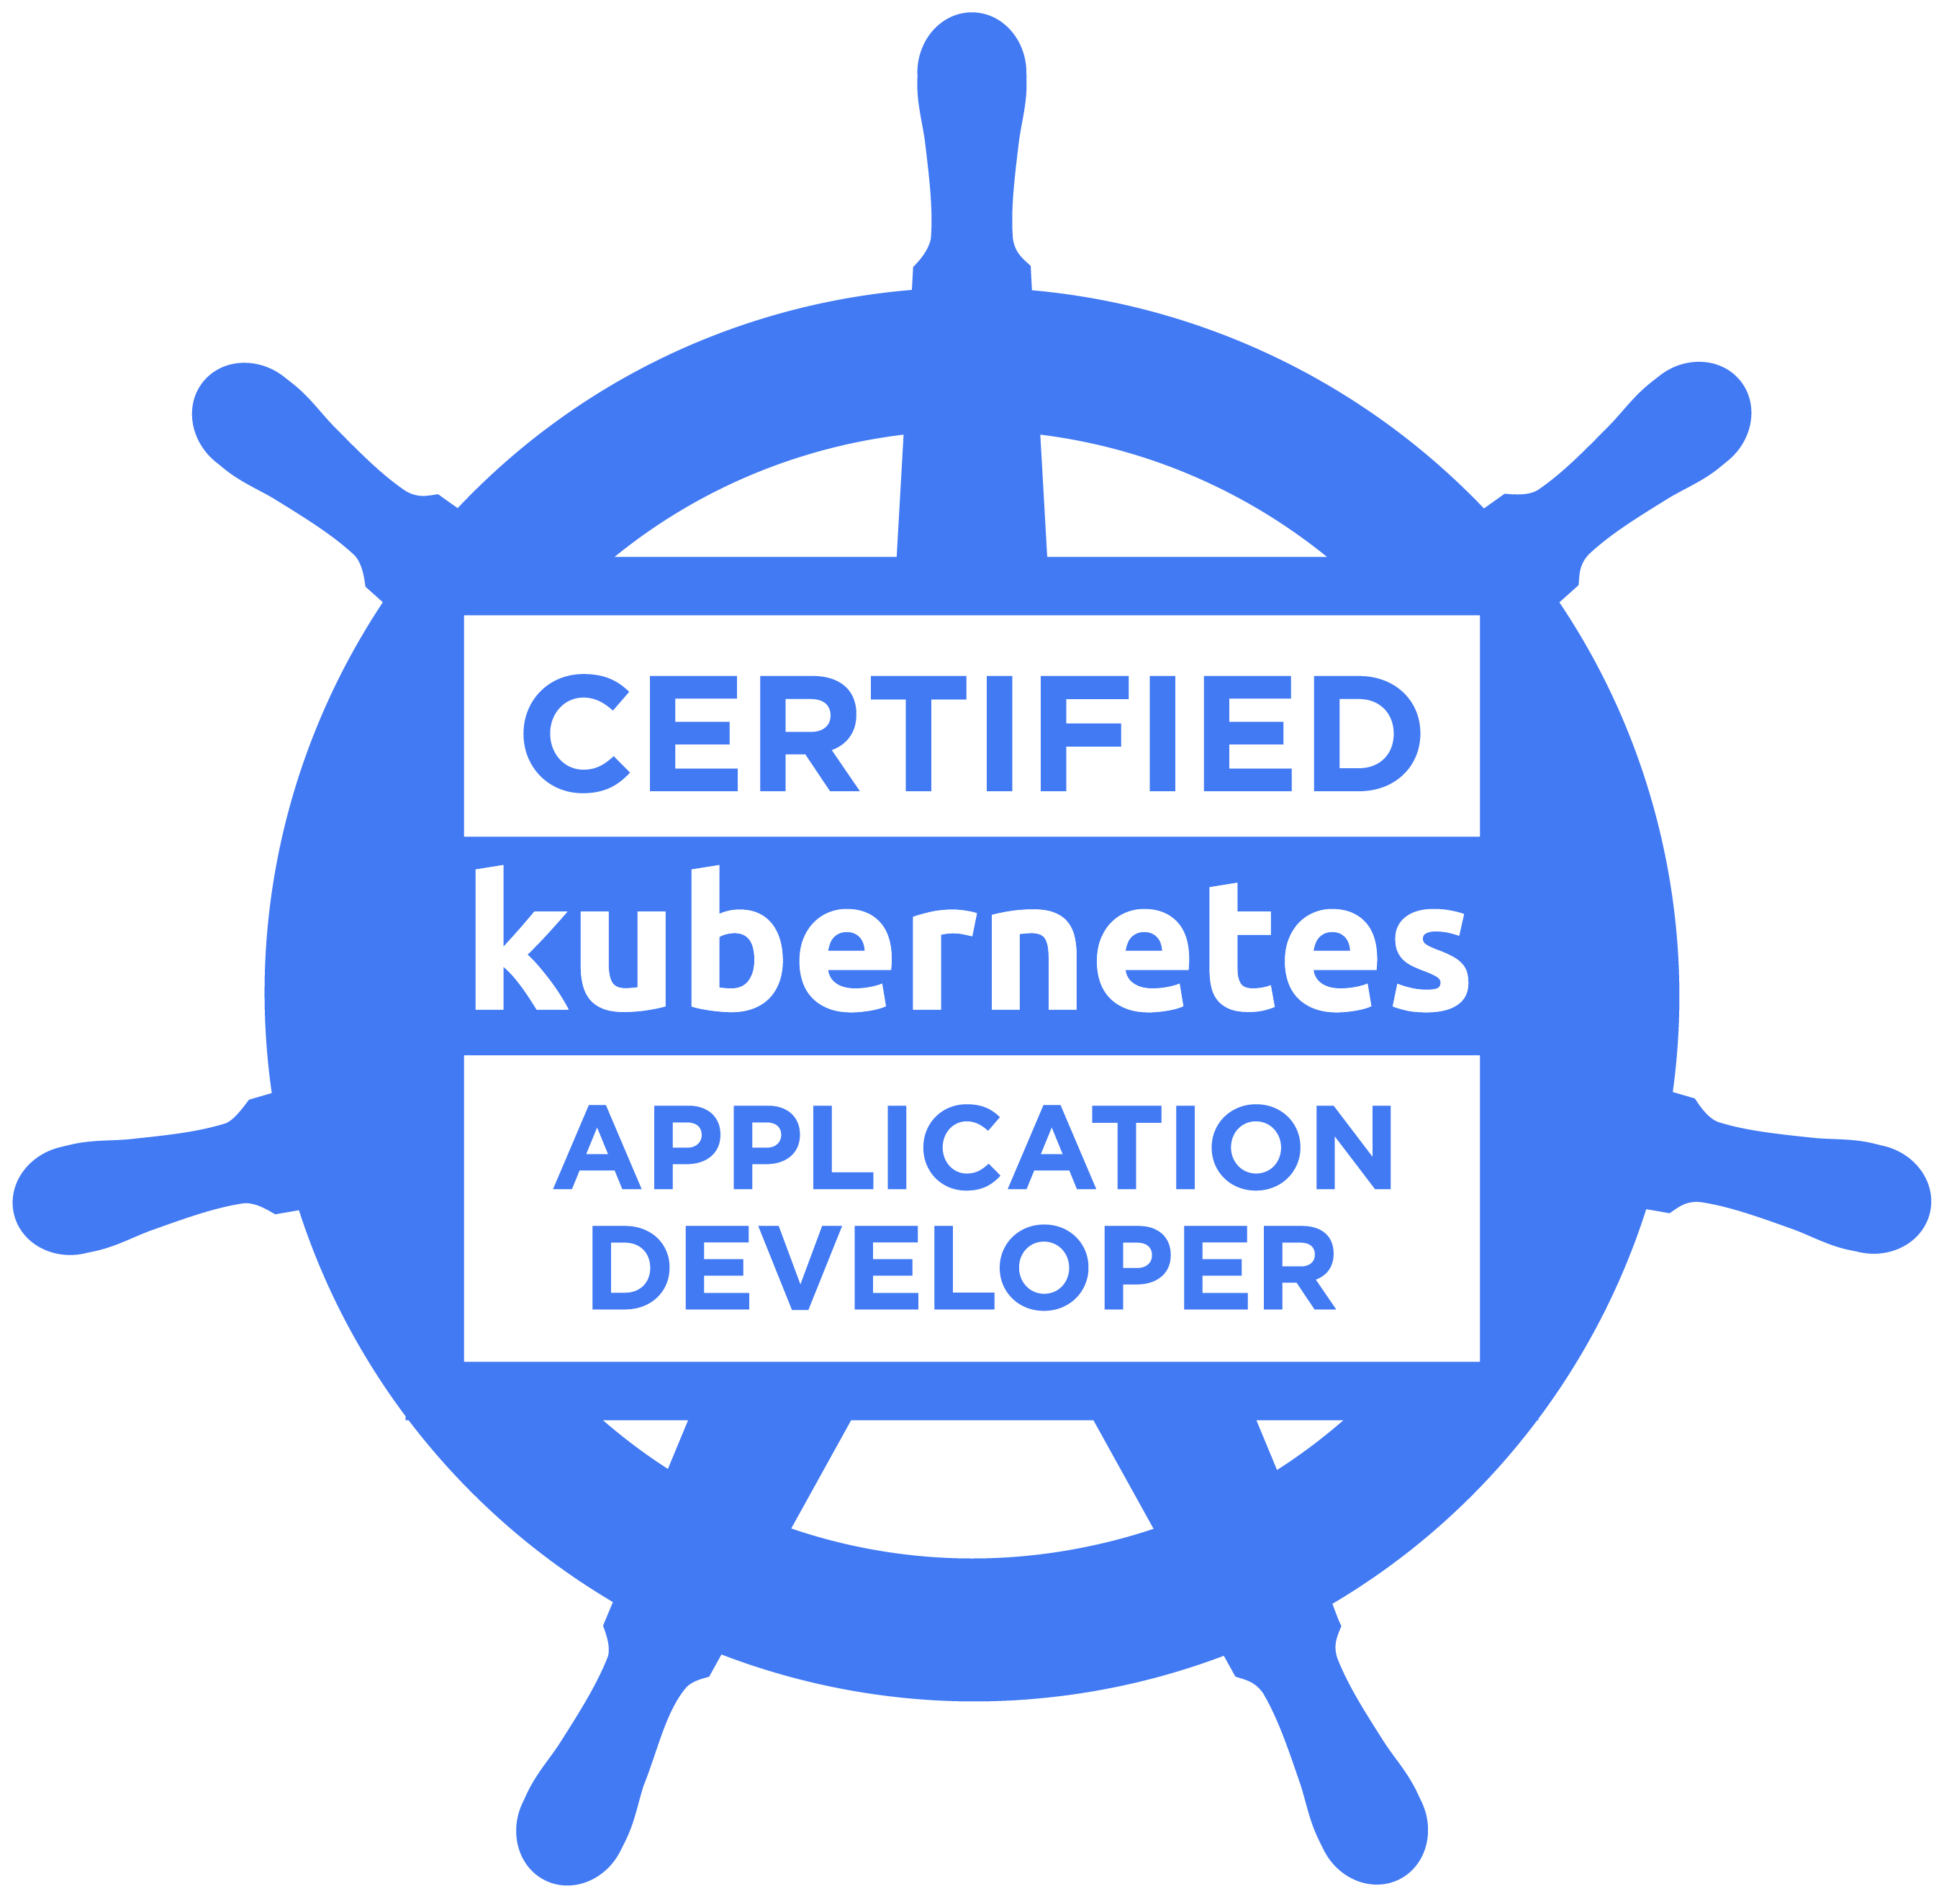
Imran Awan
Senior DevOps / Kubernetes Platform Engineer | AWS (EKS) | OpenShift | Terraform | CI/CD | Vault
London, UK | Email: imranfawan@hotmail.com | Mobile: 07958 350 442 | LinkedIn: https://uk.linkedin.com/in/imran-awan-745675b | GitHub: https://github.com/i-awan

PROFILE
Senior DevOps/Platform Engineer. 22+ yrs in IT. Specialising in Kubernetes platform engineering across On-Prem (Rancher, KubeAdm), AWS EKS and Red Hat OpenShift for Tier-1 banks, media and Government organisations. Designed and built production-grade EKS clusters via Terraform for corporate banks. Aligned to strict security/networking controls within finance, enabling deployment of numerous critical workloads with high availability. Drove CI/CD at scale (Jenkins, RedHat Tekton CD templates, Harness, Concourse, Circle CI). Secured secret management (Vault, AWS Secrets Manager). Accelerating deployments and improving reliability. Mentored and SME for Kubernetes enablement and MLOps (Airflow, model deployment) in regulated environments. Certified in Kubernetes CKAD.

CORE SKILLS
- On-Prem Kubernetes (KubeAdm) / EKS / OpenShift Platform: Helm, Ingress/Nginx, NetworkPolicy, RBAC, Operators
- Cloud & IaC: AWS (VPC, IAM, EKS, RDS, S3, PrivateLink, Endpoints), Terraform (modules), Ansible
- CI/CD: Jenkins (Pipeline as Code/Groovy), GitLab CI, Tekton, Harness, GitHub Actions; Artifacts: Nexus/Artifactory
- Security & Secrets: HashiCorp Vault (Kubernetes auth/agents), AWS Secrets Manager, TPAM; SAST/DAST/Container scanning
- Observability: Elasticsearch/Fluentd/Kibana (EFK), Grafana, Prometheus, Alert manager, ElastAlert
- Programming: Bash (advanced), Python (intermediate); plus: Go basics

EXPERIENCE
HSBC — Kubernetes SME | Remote/Canary Wharf, London | Sep 2024 – Present
Scope: Kubernetes enablement for an integral reporting team; platform is On-Prem Kubernetes with strict security controls.
- Deployed Apache Airflow to non-prod and prod clusters; containerised DAG components and standardised Helm releases.
- Integrated namespaces with HashiCorp Vault (Kubernetes auth/vault agent) to eliminate static secrets and meet AppSec controls.
- Authored Helm charts and built hardened Docker images; created templates that streamline new-service onboarding.
- Provisioned namespaces and CI/CD paths; enabled repeatable deployments via Jenkins where appropriate.
- Delivered KT documentation and demos; mentored engineers and reduced operational friction for platform consumers.
Selected Achievements:
- Delivered stable Airflow on K8s supporting production workflows and SLA compliance.
- Established Vault-integrated secret management patterns adopted by the wider team.
CITI Bank — DevOps Engineer | Remote/Canary Wharf, London | Apr 2024 – Aug 2024
Scope: Markets data division; OpenShift (On-Prem) migrations, CI/CD standardisation with Helm/Harness.
- Migrated services to Red Hat OpenShift via Helm; created Spark cluster Helm templates and standardised release patterns.
- Built new Helm charts from scratch for micro-services; integrated with Harness for gated deployments.
- Collaborated using GitFlow across Jira; scripted YAML pipelines for chart packaging and promotion.
- Contributed to platform upgrade and app migrations to OpenShift; resolved cluster/platform issues with OCP tooling.
Selected Achievements:
- Accelerated app migration by providing reusable Helm templates and clear deployment runbooks.

CRISIL (Vendor) at Citi (Client) — Senior OpenShift DevOps Engineer | Remote/Canary Wharf, London | Oct 2023 – Mar 2024
Scope: Risk & Rates division; CI/CD modernisation across OpenShift using Tekton (build) and Harness (deploy).
- Packaged micro-services with Docker and Helm; pushed artifacts to Nexus and automated promotions.
- Scripted Jenkins (Groovy) and internal YAML pipelines to build/publish images and Helm charts at scale.
- Used Harness to deploy Helm charts to OpenShift; troubleshot OCP cluster issues and improved release reliability.
Selected Achievements:
- Introduced standardised CI/CD blueprints that reduced manual steps and improved consistency across teams.
HSBC — DevOps / SRE Engineer | Remote, London | Dec 2021 – Sep 2023
Scope: Secure code and platform services; Internal Kubernetes Platform (IKP) and AWS EKS with bank-grade networking and security.
Designed and provisioned a production-grade AWS EKS platform via Terraform modules, aligning to bank security/network segmentation; enabled access via PrivateLink and routable VPC (reduced exposure surface; simplified compliant access).
- Engineered EKS cluster with HA networking, ingress (Nginx Ingress) and outbound egress via squid sidecar proxy, improving service availability and connectivity reliability.
- Applied IRSA to secure connectivity between Kubernetes workloads and AWS services
- Delivered reusable Terraform modules for EKS, VPCs, Endpoints, RDS Postgres
- Integrated HashiCorp Vault (Kubernetes auth + sidecar) and AWS Secrets Manager for secrets at runtime, eliminating hard-coded secrets and passing security audits.
- Built Jenkins pipelines (Groovy) to containerise and deploy micro-services to IKP/EKS, increasing deployment frequency from A/week to B/week with gated controls.
- Created and published Helm charts to Nexus; automated releases via Terraform/Harness, reducing manual change.
- Produced step-by-step run-books and delivered KT sessions to platform consumers, lowering onboarding time.
Selected Achievements:
- EKS platform used by multiple teams with reusable Terraform modules and hardened patterns.
- Vault-integrated deployments passed internal security assessments and audits.
Veterinary Medicines Directorate (UK Gov) — DevOps Engineer | Remote, London | Oct 2020 – Sep 2021
Scope: AWS/EKS platform enablement; CI/CD and secure runtime for. .NET services.
- Built Jenkins pipelines to containerise and deploy applications (Docker) targeting EKS.
- Implemented kube2iam for pod-level AWS credentials; integrated External Secrets for AWS Secrets Manager.
- Developed custom Helm charts for .NET workloads; partnered with developers to optimise images and manifests.
- Expanded logging via EFK; created jobs to route critical logs to a managed Elastic stack.
Selected Achievements:
- Hardened secret access patterns and improved observability posture for production services.
Ministry of Justice (UK Gov) — DevOps Engineer | Remote, London | Mar 2020 – Sep 2020
Scope: AWS Cloud Platform team; Terraform modules and Kubernetes templates for shared use.
- Created Kubernetes test clusters using Terraform modules (KOPS/EKS); authored Helm charts for core add-ons.
- Built GitHub Actions for Docker image pipelines; managed EFK stack updates and integrated ElastAlert notifications.
- Set up Vault Kubernetes auth method; managed SonarQube on Kubernetes for code analysis.
Selected Achievements:
- Published reusable modules/templates that reduced team setup time and improved consistency.
German Edge Cloud — Kubernetes DevOps Specialist | Remote, Frankfurt | Oct 2019 – Mar 2020
Scope: Multi-cluster operations on OpenStack; platform migrations and training.
- Maintained multiple Kubernetes clusters; migrated an OpenShift cluster to internal infrastructure.
- Deployed Cert-Manager with Let’s Encrypt; migrated Jira/Confluence to Kubernetes with Helm.
- Provisioned EFK and Postgres Operator
- Deployed KeyCloak Helm with Kubernetes.
Selected Achievements:
- Migrated Jira / Confluence to K8s. Delivered Kubernetes training sessions for developers and platform users.
River Island – Site Reliability Engineer (AWS/Kubernetes) | Jun 2019 – Sep 2019 (Contract)
Sky – DevOps Engineer (Kubernetes Specialist) | Dec 2018 – Apr 2019 (Contract)
Hitachi Vantara – Senior DevOps Engineer | Sep 2017 – Dec 2018 (Contract)
Santander - DevOps ALM Specialist | Apr 2017 – Aug 2017 (Contract)
HSBC – DevOps QA Tooling Specialist | Jun 2016 – Mar 2017 (Contract)

Experience beyond 10 years please see LinkedIn profile

KEY / OPEN-SOURCE PERSONAL PROJECTS
- EKS Cluster (Terraform) — Full module set to provision production-ready EKS (network, cluster, add-ons). https://github.com/i-awan/eks_cluster
- On-Prem Kubernetes Cluster — Terraform/Ansible/kubeadm bootstrap with CNI/Ingress/PSP-equivalents. https://github.com/i-awan/terraform_onprem_cluster
- Vault to K8s Secret — K8s Job in a Helm chart to sync Vault secrets into Kubernetes Secrets.
https://github.com/i-awan/vault-to-k8s-secret
- K8s Secret Manager Operator — CRD-driven sync from AWS Secrets Manager → K8s Secrets. https://github.com/imranfawan/helm-charts/tree/main/charts/k8s-secret-manager-operator

SELECTED LINKEDIN RECOMMENDATIONS
“Imran played an instrumental role in building efficient CI/CD pipelines, automating processes, and deploying security scanning solutions to the Cloud. His proactive problem-solving and teamwork consistently deliver solid results.”
— Cyber Security Manager, HSBC
“Imran tackles any AWS or Terraform problem with ease. His deep expertise in AWS, Terraform, and Kubernetes has helped our projects immensely, and he’s an all-around great colleague to work with.”
— Team Member, HSBC
“Imran is a key SME on a priority program. His knowledge of cloud computing and AWS leadership have been critical to the project’s success. I’d happily recommend him as a Cloud/Kubernetes expert.”
— Project Manager, HSBC

CERTIFICATIONS
CKAD – Certified Kubernetes Application Developer (Linux Foundation). Credential ID: CKAD-1900-001618-0100. 2019

EDUCATION
HND in Internet Computing — Thames Valley University — Merit (2001–2003)
A-Levels: Mathematics, Physics (1999) | GCSEs: Maths (B), Physics (B), Core Science (C), Further Science (C)

